Regular symposium paper
Paper Title

First name Last name ¹, First name Last name ² and First name Last name ^{2,*}
¹ Affiliation 1; e-mail@e-mail.com
² Affiliation 2; e-mail@e-mail.com
* Correspondence: e-mail@e-mail.com

Abstract: A single paragraph of about 150~300 words to give a brief introduction to your work.

Keywords: keyword 1; keyword 2; keyword 3 (List three to ten pertinent keywords)
1. Introduction
Please use 1~2 pages to prepare your regular symposium abstract paper submission.
The introduction should briefly place the study in a broad context and define the purpose of the work and its significance.
You can use the titles “Materials and Methods”, “Results”, “Discussion” and “Conclusions” (optional).
2. Section (Heading 1)
Main text paragraph.
2.1. Subsection
Main text paragraph.
3.1.1. Subsubsection
Main text paragraph.
2.2. Figures, Tables and Schemes
All figures and tables should be cited in the main text as Figure 1, Table 1, etc.

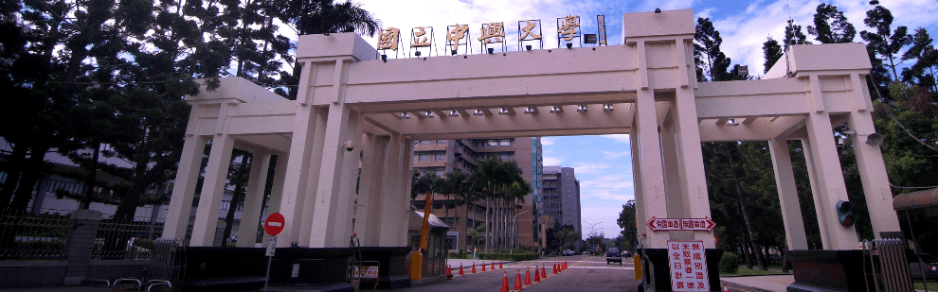
Figure 1. This is a figure.

Table 1. This is a table.
Title 1 | Title 2 | Title 3
entry 1 | data | data
entry 2 | data | data ¹
¹ Tables may have a footer.

2.3. Formatting of Mathematical Components
This is an example of an equation:
y=mx+c (1)
The text following an equation need not be a new paragraph. Please punctuate equations as regular text.

References
References must be numbered in order of appearance in the text (including citations in tables and legends) and listed individually at the end of the manuscript.
In the text, reference numbers should be placed in square brackets [ ] and placed before the punctuation; for example [1], [1–3] or [1,3].

- Author 1, A.B.; Author 2, C.D. Title of the article. Abbreviated Journal Name Year, Volume, page range.
- Author 1, A.; Author 2, B. Title of the chapter. In Book Title, 2nd ed.; Editor 1, A., Editor 2, B., Eds.; Publisher: Publisher Loca-tion, Country, 2007; Volume 3, pp. 154–196.
- Author 1, A.; Author 2, B. Book Title, 3rd ed.; Publisher: Publisher Location, Country, 2008; pp. 154–196.
- Author 1, A.B.; Author 2, C. Title of Unpublished Work. Abbreviated Journal Name stage of publication (under review; ac-cepted; in press).
- Author 1, A.B. (University, City, State, Country); Author 2, C. (Institute, City, State, Country). Personal communication, 2012.
- Author 1, A.B.; Author 2, C.D.; Author 3, E.F. Title of Presentation. In Title of the Collected Work (if available), Proceedings of the Name of the Conference, Location of Conference, Country, Date of Conference; Editor 1, Editor 2, Eds. (if available); Publisher: City, Country, Year (if available); Abstract Number (optional), Pagination (optional).
- Author 1, A.B. Title of Thesis. Level of Thesis, Degree-Granting University, Location of University, Date of Completion.
- Title of Site. Available online: URL (accessed on Day Month Year).

